NY UPMA ALICE PHELPS SCHOLARSHIP
For Undergrad Students
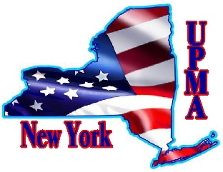

This scholarship is available to the child or grandchild of a Postmaster, Postmaster Retired, or EAS Member of UPMA currently enrolled in a college or trade school

STUDENT INFORMATION: PLEASE PRINT CLEARLY

1. Student full name: ______________________________________________________________

Address:_________________________________________________________________________

Date of Birth: _______________ Phone______________________

Email address: ____________________________________________________________________

3. Father’s Name:_____________________ Mother’s Name: ____________________________

__
4. NAME & OFFICE OF MEMBER PARENT OR GRANDPARENT (circle one)

_______________________________________________

ADDRESS__________________________________________________________________________

5. College or Trade School you are enrolled in: __________________________________________

6. Course of study you are pursuing: ___________________________________________________

Application form to be accompanied by the following:
- Proof of enrollment provided by the school on their letterhead
- Resume of scholastic and extra curricular activities, employment history, community service, leadership positions held, and awards or honors received.
- Two letters of recommendation
- A biographical letter (no more than 400 words) discussing your career goals, and a challenge you’ve faced at school, and how you handled it.
- A picture of the applicant (to be published in the ESP if scholarship is awarded)

__________________________________ ______________________________
Signature & Date of Application

APPLICATION DEADLINE: Must be postmarked by April 10, 2026
Send completed application to: Carol Commisso, 11 Ambassador Dr., Victor, NY 14564
Email any questions to ccommisso12@gmail.com

