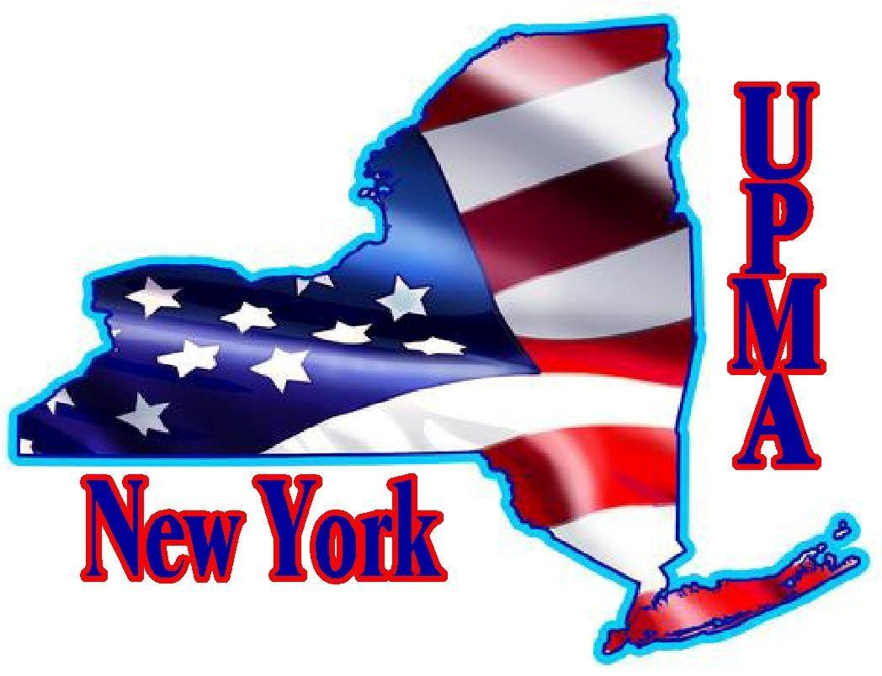
Frank & Helen Burger Scholarship
SCHOLARSHIP APPLICATION
NEW YORK CHAPTER UPMA
2026
Student’s Full Name: _____________________________________________________________________________________
Address: _____________________________________________________________________________________
City: _________________________ State: ______________ Zip ________ Date of Birth: ________________________
Phone Number: ____________________________________
Email Address: ___________________________________________________________________________
College or Trade School You Plan to Attend: ______________________________________________________________________
Have you been accepted? _______ Attach copy of acceptance letter
Mother’s Name: ________________________________ Father’s Name: ____________________________________
Name of Member Parent or Grandparent : ___________________________________________________________
Address: __________________________________________________ _____________ Phone:__________________
NYS UPMA Member is:
Postmaster: _____ Office: _________________________________ Zip: ____________
Postmaster Retired: _____Office: _________________________________ Zip: ____________
This scholarship is only available for the child or grandchild of a Postmaster, or Retired Postmaster.
THIS APPLICATION FORM MUST BE ACCOMPANIED BY:
- College or Trade School acceptance letter
- High School Transcript
- Personal resume of scholastic activities, extracurricular activities, sports, employment history, community service, clubs, positions held, and awards or honors received.
- Applicant’s personal statement. Please write a statement in which you discuss a personal experience or achievement in your life. Describe how it relates to your aspirations for the future.
- Two Letters of recommendation.
- A picture of the applicant. Will be published in the Empire State UPMA magazine.
Eligible student applicant must be a high school senior who will graduate in December 2025 or a high school senior who will graduate in May/June 2026.
APPLICATION DEADLINE: Must be postmarked by April 10, 2026.
Send completed application to: Carol Commisso, 11 Ambassador Dr., Victor NY 14564
Email any questions to: ccommisso12@gmail.com

