NEW YORK CHAPTER UPMA FISCAL POLICY

Amended October 18th, 2025
The purpose of the policy is to provide guidelines for those having the responsibility for authorizing and accounting for funds, expenditures, and property of the New York Chapter of UPMA, and to provide for the routine review of such expenditures and procedures.
SECTION I - GENERAL POLICIES
1. A financial Audit Committee consisting of the President, Secretary/Treasurer, District Coordinator, or representative from each of the five UPMA districts shall meet a minimum of once each year, at the pre- State Convention board meeting as set by the state constitution.
2. These audits are to include the financial statements and supporting documents from each month for Jan 1 through Dec 31 for the secretary/treasurer and scholarship chair and from State Convention to State Convention respectively for the districts. A list of audit requirements is included in Attachment A of this fiscal policy. The checklist will be completed, and members of the audit committee will sign off on the check list. The findings of the committee will be presented to the general membership at the meeting following the audit.
3. The State Secretary-Treasurer shall provide all monthly filings of reimbursement vouchers, receipts, and check stubs; VISA payments with vouchers and receipts attached; bank statements for the month applicable period to the audit committee for the audit. An annual report, by budget category is to be sent to the members of the State incoming Executive Board. In addition, a copy of the UPMA budget for the current year and the prior year’s financial report shall be published in the next issue of the ESUPMA, or in an issue as soon thereafter as practicable after the incoming board meeting.
4. In accordance with the state constitution the Executive Board shall have an annual audit conducted by an independent audit company and taxes submitted by a tax Accountant of recognized standing. This report will be sufficient for the state audit and copies of the report, and taxes paid will be supplied to the executive board at the pre-convention board meeting.
5. A Budget Committee, of which the Secretary-Treasurer shall be one, will be appointed by the President. The committee will prepare an annual budget to be presented to the Executive Board and for approval by the Executive Board.
6. UPMA recognizes the Signature Federal Credit Union will be the depository for all chapter funds. Credit Union VISA cards will be issued to the Secretary-Treasurer and President for chapter expenses. At no time are the cards to be used for personal expenses, and receipts must be voucher secured and filed monthly to match any listings on the monthly statement.
7. The Secretary-Treasurer will give a stipend of up to$3000.00 from the due’s money to each of the five districts annually to conduct their business. No account at any time shall exceed the $3000.00.

8. Any 3 digit/county meetings wanting to start up will be given a $100 startup fee paid by the state. Must call President for monetary approval.

9. The Legislative reimbursement travel fund will be determined annually by the Executive Board.
10. Postmasters Retired: Recognizing the valuable contribution made by the Postmasters Retired to the chapter, an annual sum will be given to the Postmasters Retired organization in the amount of 50% of their 25% dues money received per active paying member, to aid them in their endeavors. This is determined by the Retiree Executive Board.
11. Retiree’s State Convention registration fee will be set at 75% of actives registration fee
12. Committee expenses to be pre-approved by the committee chairman, the State President and Secretary-Treasurer. Chapter Member Representatives expenses are pre-approved by the Vice President Chapter Member Representative Chair, the State President and Secretary-Treasurer.
13. The financial audit will be conducted for each of the five districts at the pre–State Convention board meeting and anytime there is a change in District Coordinator position of a District. These audits are to include the financial statements and supporting documents from the past 12 months.
Attachment B will include a checklist to be followed and signed off when completed. Failure to complete the audit will prevent the payout of chapter assessment share for that district until this obligation is met.
14. The district monies are for the purpose of enhancing membership and legislative involvement. (Attachment C)

15. As stated in the New York State UPMA Chapter Bylaws: Individual items on the approved Budget shall not be exceeded without specific authorization of the Chapter President or Secretary Treasurer and disbursed on receipt of paper vouchers approved by the President. The total annual approved budget shall not be exceeded by more than 5% except by the consent of 2/3 of the Board of directors.

16. Violations of this fiscal policy will be reported by any member of the Executive Board to an ethics committee. The ethics committee will be selected annually, at the incoming board conference. It will be comprised of five members of the State Executive Board selected as follows: two members appointed by the state president and the other three members by random drawing of the remaining members of the State Executive Board. These members immediately will select a committee chair. This committee will be charged with investigating violations and reporting results to the State Executive Board for any necessary action. Necessary actions could include, but not be limited to, removal from an elected/appointed position, and/or monetary reimbursement.

SECTION II - REIMBURSEMENT
1. Reimbursement of authorized expenses will be accomplished using a New York UPMA expense voucher (Attachment E) submitted to the Secretary-Treasurer within sixty (60) days of the event at which the expenses were incurred. Vouchers received later than 60 days will not be paid unless extenuating circumstances occurred, and the Executive Board approves the reimbursement.
2. Vouchers must be filled out completely with all heading information, and a signature to be considered valid. All required receipts and/or supporting documentation must accompany each voucher. Incomplete vouchers will be returned to the sender.
3. Districts should make the announcement of time & place of their district meetings in the ESUPMA. ESUPMA is the state communication tool sent to all members. In addition, the chapter website is available and will be utilized to post the same information. Notifications electronically may also be used in addition to the ESUPMA magazine. Or at each districts expense they may mail notifications.
4. Time and place committee: upon submission of a properly completed voucher, members of the time and place committee for state convention will be reimbursed for mileage and meals per fiscal policy (only) when making site visits to potential properties.
5. Local travel: when using your POV for authorized state travel the mileage reimbursement rate will be that of the USPS mileage rate per mile (rounded to the next penny).
6. Registration Fees: Paid in full for members authorized to attend events by President in writing and submitted with the voucher.
7. Meals: Officers authorized for reimbursement of meals will be entitled to the limits of ($20.00 breakfast, $20.00 lunch, $40.00 dinner). When a meal is provided at an event, that cost will be deducted from that day's allowance. Entertainment expenses are not included.
8. Lodging: Rooms will be reimbursed for members entitled to this expense at the rate determined for the specific event and not to include tips of any kind. Valet parking is also not covered unless it is specified in what will be reimbursed for.
9. Transportation: When options for transportation are available, a cost comparison should be done, and the most economical mode of transportation will be used as the rate of reimbursement.
10. Equipment: The purchasing of equipment will be limited to memory devices, programming, and minor devices necessary for the business of conducting important state business.

SECTION III –AUTHORIZED EXPENSES BY OFFICER AND EVENT OFFICERS:

STATE PRESIDENT

1. Bond Fees
2. Development seminars
3. Travel and meals to District meetings.
4. Postage, supplies and travel necessary for conducting state business
5. Specific events as listed in this section

SECRETARY-TREASURER
1. Bond fees
2. Development seminars
3. Travel and meals at meetings when representing the President
4. Postage, supplies and travel necessary for conducting state business

5. Specific events as listed in this section
6. the Sec/Treasurer position will receive a payment of 3% of monthly dues, on a quarterly basis. When a new Sec/Treasurer takes office, payment is prorated based on time of service.

EDITOR
1. Approved Development seminars
2. Postage, supplies and travel necessary for state business
3. Specific events as listed in this section

WEB MASTER
1. Approved Development seminars
2. Postage, supplies and travel necessary for state business
3. Specific events as listed in this section

EXECUTIVE VICE PRESIDENT Membership Chair
1. Approved Development seminars
2. Postage, supplies and travel necessary for state business
3. Specific events as listed in this section

VICE PRESIDENT Education Chair
1. Approved Development seminars
2. Postage, supplies and travel necessary for state business
3. Specific events as listed in this section

VICE PRESIDENT LEGISLATIVE CHAIR
1. Travel and meals at meetings with elected state and federal representatives
2. Approved Development seminars
3. Postage, supplies and travel necessary for state business
4. Specific events as listed in this section

VICE PRESIDENT Chapter Member Representative Chair
1. Travel and meals at meetings with USPS representatives, UPMA members and Chapter Member Reps
2. Approved Development seminars
3. Postage, supplies and travel necessary for state business
4. Specific events as listed in this section

VICE PRESIDENT PAC CHAIR
1. Approved Development seminars
2. Postage, supplies and travel necessary for state business
3. Specific events as listed in this section

Chapter Member Representative EXPENSES
1. Travel, meals, postage and supplies necessary on a case-by-case basis as determined by the Chapter Member Representative Chair and / or State President

Bylaws, Fiscal Policy Chair
1. Approved Development seminars
2. Postage, supplies and travel necessary for state business
3. Specific events as listed in this section

SCHOLARSHIP CHAIR

1. Postage, supplies and travel necessary for state business
2. Specific events as listed in this section

PARLIAMENTARIAN
1. Specific events as listed in this section

DISTRICT COORDINATORS
1. Postage, supplies and travel necessary for state business
2. Specific events as listed in this section

CONVENTION CHAIR
1. Postage, supplies and travel necessary for state business
2. Specific events as listed in this section

EVENTS:

DISTRICT MEETINGS

District Coordinators (of that District)
1. Meals and mileage.
2. Lodging if more than 100 miles from home and as approved by President and Secretary-Treasurer

All expenses
. President

All expenses when invited by the President and required reports must be given
. Retiree President
Secretary-Treasurer
. Editor
. Web Master
. Executive Vice President (Membership Chair)
. Vice President (Education Chair)
. Vice President (Legislative Chair)
. Vice President (PAC Chair)
. Vice President (Chapter Member Representative Chair)
. Bylaws, Fiscal Policy Chair

Incoming Board Conference
All expenses (reports and agenda items must be prepared and copies attached to vouchers for expenses to be paid). Projected agenda and expenditures for Jan 1 through Dec 31 of the following year.
. Retiree President
President
. Secretary/Treasurer
. Editor
. Webmaster
. Executive Vice President (Membership Chair)
. Vice President (Education Chair).
. Vice President (Legislative Chair)
. Vice President (PAC Chair)
. Vice President (Chapter Member Representative Chair)
. Parliamentarian
. District Coordinators or one designee per District Coordinator
. Immediate Past President
. Immediate Past Secretary-Treasurer 1 year
. Scholarship Chair
. Convention Chair / Co-Chair
. Bylaws, Fiscal Policy Chair
. Any others invited by the President

LEGISLATIVE CONFERENCE
Any member not reimbursed by the State who attends the Legislative Conference shall be reimbursed per the travel fund determined at the incoming Executive Board Conference provided the member attends the pre-legislative meeting and all assigned Hill appointments.

All expenses

Retiree President

President
Executive Vice President (Membership Chair) in the absence of the President.
Secretary-Treasurer
Editor
Vice President (Legislative)
Vice President (PAC)

CMR Academy

All expenses

President

Executive VP

CMR VP

All others set by stipend approved by the Executive Board.

Membership Kick-off

All expenses

President
Secretary-Treasurer
Any other member approved by the President. Substantial recruiting will be the criteria.

ATLANTIC CONFERENCE

All expenses
All Executive Board members.
All others set by stipend approved by the Executive Board.
Any member not reimbursed by the State who attends the Atlantic Conference shall be reimbursed per the travel fund determined at the incoming Executive Board Conference.

STATE CONVENTION

All expenses

Retiree President

President
Secretary-Treasurer
Editor
Web Master
Convention Chair and Co-Chair
Registration Chair
Hospitality Chair
Executive Vice President (Membership Chair)
Vice President (Education Chair)
Vice President (Legislative Chair)
Vice President (PAC Chair)
Vice President (Chapter Member Representative Chair)
Bylaws, Fiscal Policy Chair
District Coordinator or one designee per District Coordinator
Scholarship Chair
Sergeant of Arms
Parliamentarian
Immediate Past President
Immediate Past Secretary-Treasurer 1 year

All others will be reimbursed per the travel fund determined by the executive board.

Reimburse registration fees for any first-timer ever at a convention. Their sponsor when notated on their registration form who they sponsored.

NATIONAL CONVENTION

All expenses

President (including one guest travel and registration)
Secretary-Treasurer (including one guest travel and registration)

All expense when invited by President to attend, and when participating in training or activities scheduled specific to their office at the convention

Editor

Webmaster
Executive Vice President (Membership Chair)
Vice President (Education Chair)
Vice President (Legislative Chair)
Vice President (PAC Chair)
Vice President (Chapter Member Representative Chair)
Bylaws, Fiscal Policy Chair

ATTACHMENT A

NEW YORK CHAPTER Secretary/Treasurer AUDIT REQUIREMENTS
Checks - accounted for, on the appropriate monthly bank statement and have dual signature vouchers - complete, with receipts attached.
Transfers - complete, appear on appropriate bank statement and appear on the receiving account statement and presented at the State Convention pre-board meeting.
VISA statements correct and account for, all transfers to and from Visa account are accounted for on appropriate bank statement. The Independent audit company results is sufficient for the audit when completed and presented.
Last Independent Audit Date: ______________
Audit Co: ____________________________________
Taxes Filed Date: ______________________
Bonds purchased Date: ___________________
Bond Company: _________________________
All the above requirements have been met and the following members are witnesses to this.
audit, dated: _______________________
Chairman of Audit: ________________________
Secretary-Treasurer: ______________________

ATTACHMENT B

New York Individual District AUDIT REQUIREMENTS
Checks: accounted for and appear on a monthly bank statement.
Vouchers - complete, with receipts attached.
Annual Reports presented at the State Convention pre-board meeting.
An audit will be conducted prior to a new District Coordinator taking over.
All the above requirements have been met and the following members are witnesses to this audit,
Dated: __________________________________
Chairman of Audit: ________________________
District Coordinator: ________________________

ATTACHMENT C

Ideas for use of District Assessment funds:
A portion of these funds may be allotted for an incentive for the Legislative Conference.
Set supplemental amounts for travel incentives for travel to/from UPMA events or cost of meals at District events.
Supplement or Pay members meals at swing meeting for first timers, retirees, or the membership in general.
Supplement or Pay registration fees at UPMA events.
Provide training for district members (i.e.: printouts, guest speakers, memory tools for personal computers etc.).
Plan special events, such as a picnic or seasonal celebrations, for the purpose of membership drives.
Purchase of incentive items for first timers attending District meetings.
Congressional and Senatorial representatives hold local activities and as a district you may supplement the cost of your members attending and discussing UPMA issues with the Representative.
Flowers given at a max value of $100.00 for any scenario requiring them.
* All ideas and money spent should first be presented to the membership of that District in the form of a motion made, discussed, and approved by the majority at a swing meeting, when possible.
*********************************

ATTACHMENT D

NYS UPMA Scholarship Awards

1. EDWIN D. JENNISON Sr. Memorial Scholarship

2. Frank and Helen Burger Scholarship

3. CD Interest – We will renew the CD Jan. 20th, 2024, for the entire amount. It shall remain in place and continued to be rolled over at the best rate until January 2029 at such time any interest above the $100,000 will be divided equally between the Burger and Jennison scholarships. Should we have to cash in the CD prior to the 5-year mark any available interest will be split between those same scholarships at that time.

4. Alice Scholarship

EDWIN D. JENNISON Sr. Memorial Scholarship Award

The Edwin D. Jennison Sr. Memorial Scholarship is established in memory of Ed Jennison Sr., long time Postmaster of Milton NY. Ed served as President of the NYS Chapter and after retirement became President of the NYS Retiree Chapter.

Ed was involved with the Boy Scouts, Viebey Sutton Post #124, the Knights of Columbus, and the St. James Church, Milton.

We are proud to name this Scholarship Program in his honor.

The NY Chapter of UPMA awards scholarships to qualifying students.

Eligibility: The applicants must be the child or grandchild of an active or Retired Postmaster, Manager, Supervisor or Associate, who is a member of the UPMA.
Applicant must be a high school graduate and accepted as a first-year student for fall admission to an accredited college, university or trade school.

The applicant must have a 3.0 Grade Point Average (GPA) over all including a 3.0 average for the last full year of high school.

Applicants must provide a transcript of their grades covering the most recent year of school.

Applicants must list and briefly describe awards and community service during their previous school terms. They will have to provide enough information that the committee will know what they were doing during their school term.

The applicant must provide the committee with a copy of their letter of acceptance from the college of their choice.

Advertisement and Selection: The scholarships will be advertised in the Empire State UPMA, and on the official web site for the NY UPMA.

A committee of three (3) will screen applications, judging on test scores, secondary school records, personal qualifications, and community involvement. Decision of the committee will be final.

*Items must be included with application or application will not be considered

The criteria for the funds of this scholarship are as follows:
1. Funds are to remain at a base minimum of $4000.00 in which $5000.00 was transferred from the general fund at the UPMA Fall Conference 2017
2. Funds will be built up through donations and raffles

******************************************************************************

Frank and Helen Burger Scholarship award

Eligibility: NY UPMA children or grandchildren of Postmasters or Postmasters retired who just graduated from high school in December or plan to graduate in June and are planning to attend college or a trade school are eligible to apply for a Frank and Helen Burger NY UPMA Scholarship award. NY UPMA children or grandchildren of Associate members are not eligible for this Scholarship.
All applications and other required documents must be postmarked by the application deadline.

Application must be accompanied by:
1.Student high school transcript
2. Personal resume' of scholastic activities, extracurricular activities, sports, employment history, community service, clubs, positions held, and awards or honors received.
3. Applicants personal statement. Please write a statement in which you discuss a personal experience or achievement in your life. Describe how it relates to your aspirations for your future.

The criteria for the funds of this scholarship are as follows:

1. Base to be maintained at $45,000.00 or above set by initial investments and donations. Any interest earned or additional money received unless otherwise specified can be used towards scholarship awards yearly.
a. Member initial donations and raffles $10,000.00
b. Helen & Frank Burger donation $20,000.00
c. Helen & Frank Burger donation $15,000.00

Alice Phelps Scholarship

The criteria for the funds of this scholarship are as follows:

- Donation of $202,000 from the Alice Phelps estate.
- No criteria for this scholarship was given when awarded to NY UPMA from the Alice Phelps estate.
- Base to be maintained at $100,000 in some form of interest accruing account that only the interest can be used for the Alice Phelps scholarship.
- Initial fund to be dispersed as follows:
- Bring the Jennison base to $4,000 by inputting what it is lacking.
- Disperse each year, no more than 10% of eligible available funds not part of the base.
- Applicants must meet and fulfill the listed eligibility requirements to be considered.

Eligibility:
Children or grandchildren of active or retired active NYUPMA members who just graduated from high school in December or plan to graduate in June and are planning to attend college or a trade school are eligible to apply as well as for any additional year attending a college or trade school. Any NY UPMA children or grandchildren of Associate or retired associate members are not eligible for this Scholarship.
Exchange students are not eligible.

- All applications and other required documents must be postmarked by the application deadline.
- Application must be accompanied by one of the following:
1.Student high school transcript, college or trade school enrollment
- Personal resume' of scholastic activities, extracurricular activities, sports, employment history, community service, clubs, positions held, and awards or honors received.
- Applicants personal statement. Please write a statement in which you discuss a personal experience or achievement in your life. Describe how it relates to your aspirations for your future.

ATTACHMENT E

NYS UPMA STATE VOUCHER

ATTACHMENT F

NYS UPMA DISTRICT VOUCHER

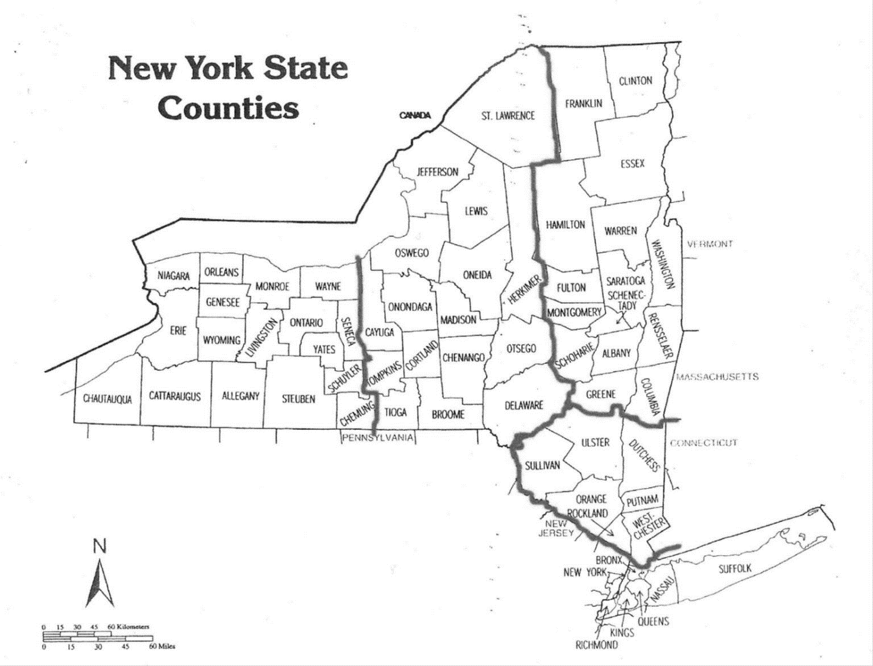District and County Map Attachment G
2nd District
3rd District
4th District
5th District
1st District
and Districts

District meetings:
Each New York UPMA district is required to hold 2 district meetings each year. These are usually held in the spring and fall. The state president is usually invited and may bring other state officers. Updates about what is happening at state and national levels are provided at these meetings. At most of these meetings Postal District management is invited to attend and do presentations on important issues affecting the Postmasters and the Postal Service. These meetings are a great opportunity for those who cannot get away to attend overnight events to meet the officers and to see how UPMA operates.

