NEW YORK CHAPTER UPMA FISCAL POLICY 2016

Effective NOV. 1ST 2016; and continuing until amended by the State Executive Board, in session, this fiscal policy will be in effect. The purpose of the policy is to provide guidelines for those having responsibility for authorizing and accounting for funds, expenditures, and property of the New York Chapter of UPMA, and to provide for the routine review of such expenditures and procedures.
SECTION I - GENERAL POLICIES
1. A financial Audit Committee consisting of the District Coordinator or representative from each of the five UPMA districts shall be appointed by the President at the Fall Conference. The committee shall meet a minimum of twice each year, prior to the meeting of the board at Fall Conference and the State Convention as set by the state constitution.
These audits are to include the financial statements and supporting documents from each month for May 1 through Oct 31 and Nov 1 through April 30 respectively. The monthly filing should include a profit and loss report for the month with a copy sent to the state president. A list of audit requirements is included in Attachment A of this fiscal policy. The checklist will be completed and members of the fiscal policy committee will sign off on the check list. The findings of the committee will be presented to the general membership at the meeting following the audit.
2. The State Secretary-Treasurer shall provide all monthly filings of reimbursement vouchers, receipts and check stubs; VISA payments with vouchers and receipts attached; bank statements for the month and a monthly Profit and Loss Statement, for the applicable time period, to the audit committee for the audit. A quarterly report, by budget category, is to be sent to the members of the State Executive Board. In addition, a copy of the UPMA budget for the current year and the prior year’s financial report shall be published in the Feb. issue of the ESUPMA, or in an issue as soon thereafter as practicable.
3. In accordance with the state constitution the Executive Board shall have an annual audit conducted and taxes submitted by a Certified Public Accountant of recognized standing
4. A Budget Committee consisting of at least five members, of which the Secretary-Treasurer shall be one, will be appointed by the President by the Fall Conference. The committee will prepare an annual budget to be presented to the Executive Board and for approval by the Executive Board.
5. The UPMA recognized Federal Credit Union will be the depository for all chapter funds. Credit Union VISA cards will be issued to the Secretary-Treasurer and President for chapter expenses. At no time are the cards to be used for personal expenses, and receipts must be voucher secured and filed monthly to match any listings on the monthly statement.
6.. The Secretary-Treasurer will give a stipend of $3000.00 from the dues money to each of the five districts annually to conduct their business.. The remaining dues money returned from the National office will remain in the general fund and disbursed as deemed necessary by the Executive Board.

7.. Legislative Funds will be determined annually by the Executive Board.
8.. Postmasters Retired: Recognizing the valuable contribution made by the Postmasters Retired to the chapter, an annual sum will be given to the Postmasters Retired organization in the amount of 50% of their 25% dues money received per active paying member, to aid them in their endeavors. This is determined by the Retiree Executive Board.
9.. Committee expenses to be pre-approved by the committee chairman, the State President and Secretary-Treasurer. Chapter Member Representatives expenses are pre-approved by the Vice President Chapter Member Representative Chair, the State President and Secretary-Treasurer.
10. After all vouchers for included events are processed the event is then closed out and all outstanding balances will be transferred to the general account with the exception of Legislative Funds.
11. The financial audit will be conducted for each of the five districts twice a year at Fall Conference and the State Convention. These audits are to include the financial statements and supporting documents from each month for May 1 through Oct 31 and Nov 1 through April 30 respectively. The monthly filing should include a profit and loss report for the month Attachment B will include a checklist to be followed and signed off when completed. Failure to complete the audit will prevent the payout of chapter assessment share for that district until this obligation is met.
12. The district monies are for the purpose of enhancing membership and legislative involvement. (Attachment C)
13. As stated in the New York State UPMA Chapter Bylaws: Individual items on the approved Budget shall not be exceeded without specific authorization of the Chapter President or Secretary Treasurer and disbursed on receipt of paper vouchers approved by the President.

And: The approved budget shall not be exceeded except by the consent of 2/3 of the Board of directors.
14. Violations of this fiscal policy will be reported by any member of the Executive Board to an ethics committee. The ethics committee will be selected annually, at the Fall Conference. It will be comprised of five members of the State Executive Board selected as follows: two members appointed by the state president and the other three members by random drawing of the remaining members of the State Executive Board. These members immediately will select a committee chair. This committee will be charged with investigating violations and reporting results to the State Executive Board for any necessary action. Necessary actions could include, but not be limited to, removal from an elected/appointed position, and/or monetary reimbursement.

SECTION II - REIMBURSEMENT
1. Reimbursement of authorized expenses will be accomplished through the use of a New York UPMA expense voucher (Attachment E) submitted to the Secretary-Treasurer within sixty (60) days of the event at which the expenses were incurred. Vouchers received later than 60 days will not be paid unless extenuating circumstances occurred, and the Executive Board approves the reimbursement.
2. Vouchers must be filled out completely with all heading information, and a signature to be considered valid. All required receipts and/or supporting documentation must accompany each voucher. Incomplete vouchers will be returned to the sender.
3. Checks issued for reimbursement must be printed with “void after sixty (60) days” for purpose of timely cashing and accounting.
4. Districts should make the announcement of time & place of their district meetings in the ESUPMA January and August issues. ESUPMA is the state communication tool sent to all members. In addition the chapter website is available and will be utilized to post the same information. Or at each districts expense they may mail notifications.
5. Time and place committee: upon submission of a properly completed voucher, members of the time and place committee for state convention will be reimbursed for mileage (only) when making site visits to potential properties.
6. Local travel: when using your POV for authorized state travel the mileage reimbursement rate will be that of the USPS mileage rate per mile (rounded to the next penny).
7. Registration Fees: Paid in full for members authorized to attend events by President in writing and submitted with the voucher.
8. Meals: Officers authorized for reimbursement of meals will be entitled to the limits of ($10.00 breakfast, $10.00 lunch, $20.00 dinner) with vouchers and receipts (as available) attached. When a meal is provided at an event, that cost will be deducted from that day's allowance. Entertainment expenses are not included.
9. Lodging: Rooms will be reimbursed for members entitled to this expense at the rate determined for the specific event and not to include maid tips or valet parking & tips.
10. Transportation: When options for transportation are available, a cost comparison should be done, and the most economical mode of transportation will be used as the rate of reimbursement.
11. Equipment: The purchasing of equipment will be limited to memory devices, programming and minor devices necessary for the business of conducting important state business.

SECTION III –AUTHORIZED EXPENSES BY OFFICER AND EVENT OFFICERS:

STATE PRESIDENT

1. Bond Fees
2. Development seminars
3. Travel and meals to District meetings, other than own and when in writing.
4. Postage, supplies and travel necessary for conducting state business
5. Specific events as listed in this section

SECRETARY-TREASURER
1. Bond fees
2. Development seminars
3. Travel and meals at meetings when representing the President
4. Postage, supplies and travel necessary for conducting state business

5. Specific events as listed in this section
6. Salary as determined by the Executive Board to be paid on April 1st and Oct 1st

EDITOR
1. Approved Development seminars
2. Postage, supplies and travel necessary for state business
3. Specific events as listed in this section

WEB MASTER
1. Approved Development seminars
2. Postage, supplies and travel necessary for state business
3. Specific events as listed in this section

EXECUTIVE VICE PRESIDENT Membership Chair
1. Approved Development seminars
2. Postage, supplies and travel necessary for state business
3. Specific events as listed in this section

VICE PRESIDENT Education Chair
1. Approved Development seminars
2. Postage, supplies and travel necessary for state business
3. Specific events as listed in this section

VICE PRESIDENT LEGISLATIVE CHAIR
1. Travel and meals at meetings with elected state and federal representatives
2. Approved Development seminars
3. Postage, supplies and travel necessary for state business
4. Specific events as listed in this section

VICE PRESIDENT Chapter Member Representative Chair
1. Travel and meals at meetings with USPS representatives, UPMA members and Chapter Member Reps
2. Approved Development seminars
3. Postage, supplies and travel necessary for state business
4. Specific events as listed in this section

VICE PRESIDENT PAC CHAIR
1. Approved Development seminars
2. Postage, supplies and travel necessary for state business
3. Specific events as listed in this section

Chapter Member Representative EXPENSES
1. Travel, meals, postage and supplies necessary on a case by case basis as determined by the Chapter Member Representative Chair

Bylaws, Fiscal Policy and National Policy Chair
1. Approved Development seminars
2. Postage, supplies and travel necessary for state business
3. Specific events as listed in this section

SCHOLARSHIP CHAIR

1. Postage, supplies and travel necessary for state business
2. Specific events as listed in this section

PARLIAMENTARIAN
1. Specific events as listed in this section

DISTRICT COORDINATORS
1. Postage, supplies and travel necessary for state business
2. Specific events as listed in this section

CONVENTION CHAIR
1. Postage, supplies and travel necessary for state business
2. Specific events as listed in this section

EVENTS:

DISTRICT MEETINGS (SPRING and FALL)

District Coordinators (of that District)
1. Meals and mileage.
2. Lodging if more than 100 miles from home and as approved by President and Secretary-Treasurer

All expenses
.President

All expenses when invited by the President and required reports must be given
.Secretary-Treasurer
.Editor
.Web Master
.Executive Vice President (Membership Chair)
.Vice President (Education Chair)
.Vice President (Legislative Chair)
.Vice President (PAC Chair)
.Vice President (Chapter Member Representative Chair)
.Bylaws, Fiscal Policy and National Policy Chair

FALL CONFERENCE
All expenses (reports and agenda items must be prepared and copies attached to vouchers for expenses to be paid)(REPORTS: Fall Board - projected agenda for Nov 1 through June 30. Convention Board - accomplishments July1 to Oct 31.
.President
.Secretary/Treasurer
.Editor
.Webmaster
.Executive Vice President (Membership Chair)
.Vice President (Education Chair).
.Vice President (Legislative Chair)
.Vice President (PAC Chair)
.Vice President (Chapter Member Representative Chair)
.Parliamentarian
.District Coordinators or one designee per District Coordinator
.Immediate Past President
.Immediate Past Secretary-Treasurer
.Scholarship Chair
.Convention Chair
.Bylaws, Fiscal Policy and National Policy Chair
. Any others invited by the President not already being paid by National

LEADERSHIP CONFERENCE

1. Hotel room night charges are to include for Leadership, the night before, nights during and the night after.
2. When potential officers are invited by the President for Leadership training, reimbursement of one night stay plus travel mileage and meals according to the mileage rate and meal rates will be afforded.

All expenses

President
Secretary-Treasurer
Editor
Webmaster
Executive Vice President (Membership Chair)
Vice President (Education Chair)
Vice President (Legislative Chair)
Vice President (PAC Chair)
Vice President (Chapter Member Representative Chair)
Bylaws, Fiscal Policy and National Policy Chair
Chapter Member Representatives

LEGISLATIVE CONFERENCE
Any member not reimbursed by the State who attends the Legislative Conference shall be reimbursed for One(1) night Hotel stay and a share of the travel expense fund to be determined annually by the Executive Board, provided the member attends the pre-legislative meeting and all assigned Hill appointments.

All expenses

President
Executive Vice President (Membership Chair)
Secretary-Treasurer
Editor
Web Master
Vice President (Legislative)
Vice President (PAC)

STATE CONVENTION

All expenses

President
Secretary-Treasurer
Editor
Web Master
Convention Chair
Registration Chair
Hospitality Chair
Executive Vice President (Membership Chair)
Vice President (Education Chair)
Vice President (Legislative Chair)
Vice President (PAC Chair)
Vice President (Chapter Member Representative Chair)
Bylaws, Fiscal Policy and National Policy Chair
District Coordinator or one designee per District Coordinator
Scholarship Chair
Sergeant of Arms
Parliamentarian
Immediate Past President
Immediate Past Secretary-Treasurer

Registration fee, travel to and from convention, parking, meals at fiscal policy prescribed rates and 50% of hotel room charge when both pre- and post- convention board meetings are attended. Any exceptions will be made at the executive board’s discretion.

Chapter Member Representatives

NATIONAL CONVENTION

All expenses

President (including one guest travel and registration)
Secretary-Treasurer (including one guest travel and registration)

All expense when invited by President to attend, and when participating in training or activities scheduled specific to their office at the convention

Editor

Webmaster
Executive Vice President (Membership Chair)
Vice President (Education Chair)
Vice President (Legislative Chair)
Vice President (PAC Chair)
Vice President (Chapter Member Representative Chair)
Bylaws, Fiscal Policy and National Policy Chair

ATTACHMENT A

NEW YORK CHAPTER AUDIT REQUIREMENTS
Checks - accounted for, on the appropriate monthly bank statement and have dual signatures

Vouchers - complete, check stub and receipts are attached
And have dual signatures
Transfers - complete, appear on appropriate bank statement and appear on the receiving account statement
Legislative Accounts received monthly transfers
Semi-Annual reports complete including a budget comparison
VISA statements correct and accounted for, all transfers to and from Visa account are accounted for on appropriate bank statement and a copy provided to the President monthly.
Last Independent Audit Date:______________
Audit Co :____________________________________
Taxes Filed Date : ______________________
Audit Cost :____________________________
Bonds purchased Date: ___________________
Bond Company: _________________________
All the above requirements have been met and
the following members are witnesses to this
audit, dated : _______________________
Chairman of Audit:________________________
Secretary-Treasurer: ______________________

ATTACHMENT B

New York Individual District AUDIT REQUIREMENTS
Checks: accounted for and appear on a monthly bank statement.
Vouchers - complete, check stub and receipts are attached
Semi Annual Reports presented at District and State Meetings.
Legislative activities accounted for
All chapter assessment transfers accounted for.
All the above requirements have been met and the following members are witnesses to this audit,
Dated : __________________________________
Chairman of Audit:________________________
District Director: ________________________

ATTACHMENT C

Ideas for use of District Assessment funds:
A portion of these funds must be spent in the Legislative area and many of the same ideas may be applied to the Legislative Conference in Washington DC.
Set supplemental amounts for travel incentives for travel to/from UPMA events or cost of meals at county events.
Supplement or Pay members meals at swing meeting for first timers, retirees or the membership in general.
Supplement or Pay registration fees at UPMA events.
Provide training for district members (i.e.: printouts, guest speakers, memory tools for personal computers etc.).
Plan special events, such as a picnic or seasonal celebrations, for the purpose of membership drives.
Purchase of incentive items for first timers attending District/County Meetings.
Congressional and Senatorial representatives hold local activities and as a district you may supplement the cost of your members attending and discussing UPMA issues with the Representative.
* All ideas and money spent should first be presented to the membership of that District in the form of a motion made, discussed and approved by the majority.
*********************************

ATTACHMENT D

NYS UPMA Scholarship Awards

1. EDWIN D. JENNISON Sr. Memorial Scholarship

2. Frank and Helen Burger Scholarship

EDWIN D. JENNISON Sr. Memorial Scholarship Award

The Edwin D. Jennison Sr Memorial Scholarship is established in memory of Ed Jennison, long time Postmaster of Milton NY. Ed served as President of the NYS Chapter and after retirement became President of the NYS Retiree Chapter.

Ed was involved with the Boy Scouts, Viebey Sutton Post #124, the Knights of Columbus, and the St. James Church, Milton.

We are proud to name this Scholarship Program in his honor.

The NY Chapter of UPMA awards scholarships to qualifying students.

Eligibility: The applicants must be the child or grandchild of an active or Retired Postmaster, Manager, Supervisor or Associate, who is a member of the UPMA.
Applicant must be a high school graduate and accepted as a first year student for fall admission to an accredited college, university or trade school.

The applicant must have a 3.0 Grade Point Average (GPA) over all including a 3.0 average for the last full year of high school.

Applicants must provide a transcript of their grades covering the most recent year of school. Also, the ACT or SAT scores must be included with application. .

Applicants must list and briefly describe awards and community service during their previous school terms. They will have to provide enough information that the committee will know what they were doing during their school term.

The applicant must provide the committee with a copy of their letter of acceptance from the college of their choice, and also must include copies of ACT, SAT or other entrance examination scores of entrance.

Advertisement and Selection: The scholarships will be advertised in the Empire State UPMA, and on the official web site for the NY UPMA.

A committee of three (3) will screen applications, judging on test scores, secondary school records, personal qualifications and community involvement. Decision of the committee will be final.

*Items must be included with application or application will not be considered

The criteria for the funds of this scholarship are as follows:
1. Funds are to remain at a base minimum of $4000.00 in which $5000.00 was transferred from the general fund at the UPMA Fall Conference 2017
2. Funds will be built up through donations and raffles

******************************************************************************

Frank and Helen Burger Scholarship award

Eligibility: NY UPMA children or grandchildren of Postmasters or Postmasters retired who just graduated from high school in December or plan to graduate in June and are planning to attend college or a trade school are eligible to apply for a Frank and Helen Burger NY UPMA Scholarship award. NY UPMA children or grandchildren of Associate members are not eligible for this Scholarship.
All applications and other required documents must be postmarked by the application deadline.

Application must be accompanied by:
1.Student high school transcript
2. College entrance board test results (SAT, ACT); Not necessary if applying for a trade school
3. Personal resume' of scholastic activities, extracurricular activities, sports, employment history, community service, clubs, positions held and awards or honors received.
4. Applicants personal statement. Please write a statement in which you discuss a personal experience or achievement in your life. Describe how it relates to your aspirations for your future.

Eligible student applicant must be a senior who will graduate or have graduated in December of the year prior to the date of this application year or will be a senior who will graduate in May/June of the application year.

The criteria for the funds of this scholarship are as follows:

1. Base to be maintained at $45,000.00 or above set by initial investments and donations. Any interest earned or additional money received unless otherwise specified can be used towards scholarship awards yearly.
a. Member initial donations and raffles $10,000.00
b. Helen & Frank Burger donation $20,000.00
c. Helen & Frank Burger donation $15,000.00

ATTACHMENT E

NYS UPMA STATE VOUCHER.

ATTACHMENT F

NYS UPMA DISTRICT VOUCHER

ATTACHMENT G

District and County Map
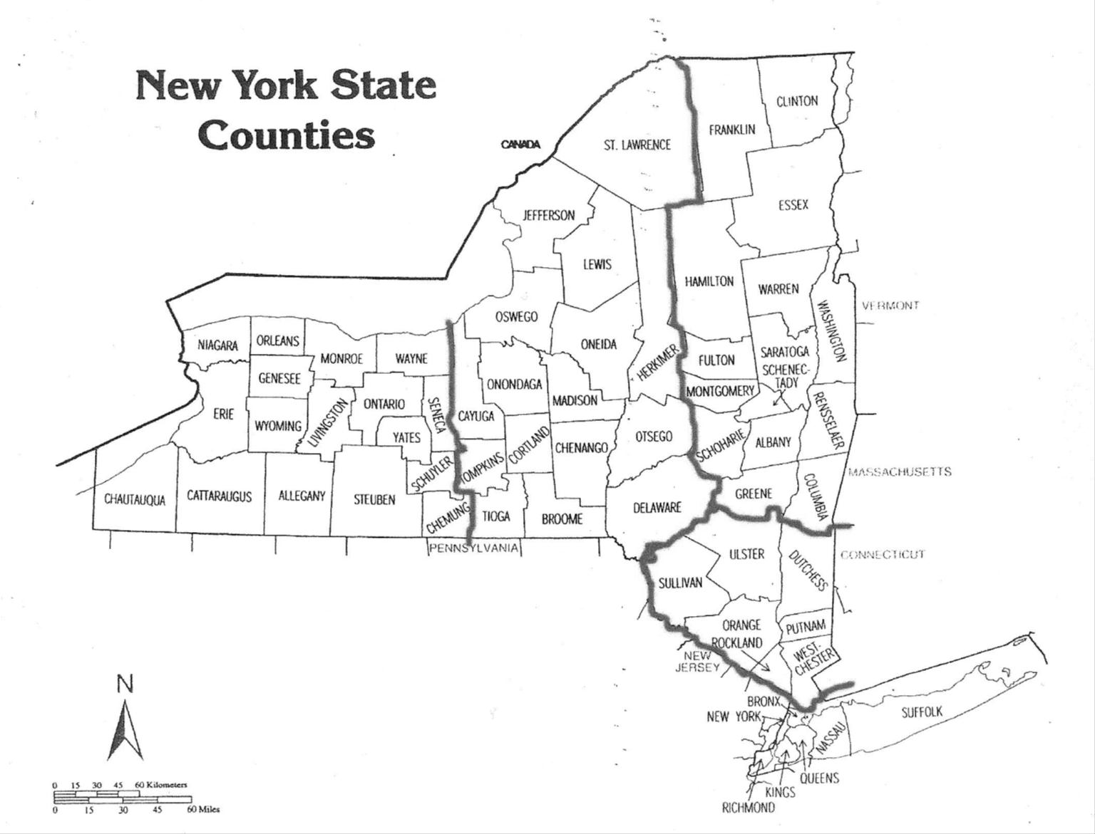
2nd District
3rd District
4th District
5th District
1st District
and Districts
District meetings:
Each New York UPMA district is required to hold 2 district meetings each year. These are held in the spring and fall. The state president is usually invited and may bring other state officers with them. Updates about what is happening at state and national levels are provided at these meetings. At most of these meetings Postal District management is invited to attend and do presentations on important issues affecting the Postmasters and the Postal Service. These meetings are a great opportunity for those who cannot get away to attend overnight events to meet the officers and to see how UPMA operates. District meetings spring and fall are made up of Counties within each District.

County meetings:
Each county within NYS has a president, vice president, secretary & treasurer (or secretary/treasurer) and a membership chair. Many counties have joined together to form multiple county associations. These meetings help resolve local concerns and help with promoting different ideas to pass up the line with State officers. Check with a local postmaster to find out how to join the county group. Most counties have 3-6 meetings a year. Most also assess a small membership fee to cover the county administrative costs such as mailing notices or paying for guests meals. These meetings can be very informative. Many counties invite a guest Postal speaker to provide information on important topics.

